**Hello Team!** **Consider the below two tables**:

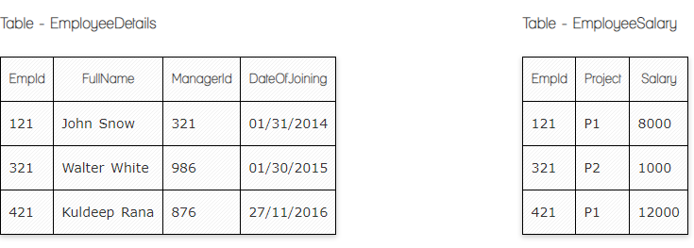

**Ques.1. Write a SQL query to fetch the count of employees working in project 'P1'.**

SELECT COUNT FROM EmployeeSalary

Group By Project

Where project=’P1’

**Ques.2. Write a SQL query to fetch employee names having salary greater than or equal to 5000 and less than or equal 10000.**

Select * from EmployeeSalary

Where salary between 5000 and 10000;

**Ques.3. Write a SQL query to fetch count of employees sorted by project's count in descending order.**

Select * from EmployeeDetails

Order by FullName desc;

**Ques.4. Write a query to fetch employee names and salary records. Return employee details even if the salary record is not present for the employee.**

**Your Answer:**

Select from EmployeeDetails.fullname, employeesalary.salary

From EmployeeDetails

Left join employeesalary on Employeesalary.empid=employeesalary.empid

Order by employeeDetails.fullname

**Ques.5. Write a SQL query to create an empty table with ‘Test’ name.**

CREATE TABLE Test (

ID int

Empty Null

)

**Ques.6. Write a SQL query to delete an empty table with ‘Test’ name.**

DROP Table Test

**Ques.7. Write a SQL query to fetch all the Employees details from EmployeeDetails table who joined in Year 2016.**

Select from EmployeeDetails

Where dataOfJoining like ‘%2016%’;

**Ques.8. Write a SQL query to insert new record to the EmployeeDetails table with any data.**

Insert into EmployeeDetails ( fullname, managerId, dateofjoining)

Values (‘Celine’,’234’,’02/08/2017’);

**Ques.9. Write a SQL query to update EmployeeSalery table with setting Salary to 2000 for Project P2.**

UPDate EmployeeSalary

Set Salary=’2000’

Where Project=p2